

**Khulna university of engineering and technology**

**Department of Electronics and Communication Engineering**

***Presented By:***

**Group no: B5**

**Abhrojit Paul Priom (1909043)**

**Sumit Das (1909044)**

**Motiya Rahman Piya (1909045)**

Course Title: **Electronic Circuits Design Laboratory**

Course no: **ECE-2200**

Date of submission: 29.12.2022

***Project name:***

***Power Amplifier***

**Project Supervisor:**

Dr. Md. Faruque Hossain

Professor

Dept of ECE, KUET.

Md. Ebtidaul Karim

Assistant Professor

Dept of ECE, KUET.

**Title:**

Designing a power amplifier with 8ohm speaker as load.

**Motivation:**

Power amplifier are essential to every home theater sound system because they perform the basic function of taking the audio signal from the output devices and amplify that signal. The function of a power amplifier is to raise the power level of input signal. So its an essential project to learn.

**Introduction:**

A power amplifier is an electronic amplifier designed to increase the magnitude of power of a given input signal .The power of the input signal leads to a level high enough to drive loads of output devices like speakers ,headphones ,RF transmitters etc. The input signal to a power amplifier needs to above a chain threshold .So instead of passing the raw audio/RF signal to the power amplifier ,it is first pre-modified and is sent as input to the power amp after making necessary modifications.

Depending on the type of output device that is connected, power amplifiers are divided into the following three types:

1. **Audio Power Amplifiers**
2. **RF Power Amplifiers**
3. **DC Power Amplifier**

For our project we set out to design an audio power amplifier .This type of power amplifiers are used for increasing the magnitude of power of a weaker audio signal .

**Objectives:**

The main objectives of this project are:

* To design a power amplifier
* To amplify or increase the input signal to produce an output signal which is much larger than that of the input with a similar waveform as that of the input.

**Methodology:**

The power supply takes the large AC signal from a household wall socket and reduces and rectifies it to the +/- 12 Volt DC signals required to operate the circuit. We here not designed the rectifier circuit as we have DC power supply in our Circuit Designing Laboratory. The prototype used a pre-built bridge rectifier for space considerations and cost effectiveness, but assembly out of individual components is an alternative. By taking the center tap of the transformer as ground, the rectified output sweeps of the bridge rectifier nodes are defined as +15 and –15 Volt peak half- 1 Fully rectified meaning that there is a signal output for both the positive and negative input sweeps 4 waves. The waves are then smoothed out by placing large (1 uF) capacitors between the positive/negative outputs and ground. The capacitors charge during the output peaks and discharge when the waves are low. This smoothies the signal into almost DC with some ripple. It is important to note that interference and feedback in the power supply was a significant problem once the entire circuit was connected. This problem was alleviated by connecting large capacitors from the positive and negative nodes to ground at multiple sites of the circuitry. The large capacitors act as shorts to AC signals only, and so any distortions propagating in the supply lines are grounded through them.

|  |  |  |  |
| --- | --- | --- | --- |
| **SI No.** | **Apparatus** | **Rating** | **Quantity** |
| **01** | Potentiometer | 10K | 1 |
| **02** | Capacitor | 1000uF,1uF,10uF | 3 |
| **03** | Resistor | 10ohm | 1 |
| **04** | op-amp | LM386 | 1 |
| **05** | Microphone |  | 1 |
| **06** | Speaker | 8ohm | 1 |
| **07** | oscilloscope | 20MHz | 1 |

**Apparatus required:**

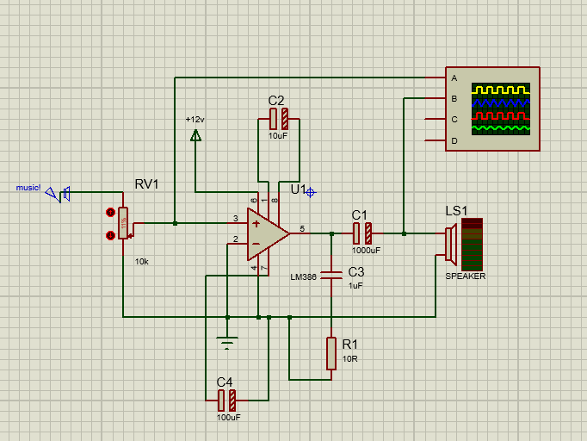**Circuit Diagram:**

Figure 1: Circuit diagram of power amplifier

**Block Diagram:**

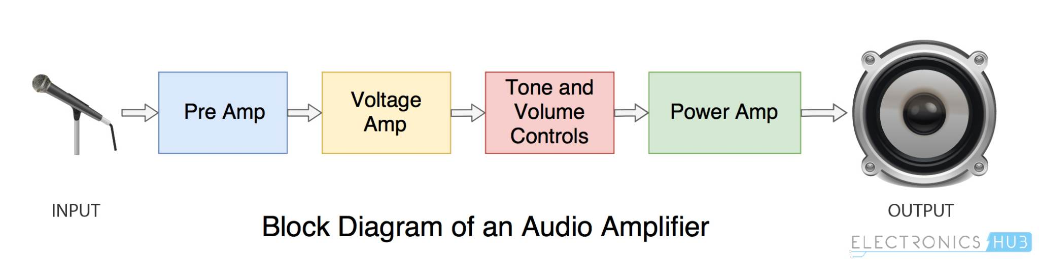

**Cost analysis:**

|  |  |  |  |
| --- | --- | --- | --- |
| **Name** | **Price(tk)** | **Quantity** | **Total Price(tk)** |
| Capacitor | 12 | 3 | 36 |
| Resistor | 1 | 1 | 1 |
| Op-amp | 15 | 1 | 15 |
| Battery | 65 | 3 | 195 |
| Variable resistor | 25 | 1 | 25 |

**Result Analysis:**

In this project we have designed a power amplifier with LM386. LM386 is a very low powered op-amp. In this project very low powered signal is used as input and we got amplified output. We gave audio signal which was only a few millivolts and we got amplified audio signal from the speaker.

**Discussion:**

While doing this project we faced some difficulties. We tried the design the circuit with LM386, but as it works in very low power we were not getting the expected results. This is because of the noise that occurred during runtime. There could be some instrumental error also. We varied the capacitor values and changed the op-amp and finally got a decent result.

**Conclusion:**

In this experiment we have implemented a power amplifier which successfully amplifies an input signal that is given into it and we could get the amplified output through a speaker.

**Critical Challenges:**

We were not getting proper output because of noises and improper equipment ratings. We changed breadboards and other equipment to get an acceptable result.

**Conflicting Requirement:**

The LM386 is supposed to give a gain of 20 to 200 when the capacitor value between pin 1 and pin 8 increases. But we were always getting the same amplified input despite changing the capacitor values of pin 1 and 8.

**Applications:**

**Consumer Electronics:** Audio power amplifiers are used in almost all consumer electronics devices ranging from microwave ovens, headphone drivers, television etc.

**Industrial:** Switching type power amplifiers are used for controlling most of the industrial actuator systems like servos and dc motors.

**Wireless communication:** High power amplifiers are important in transmission of cellular or FM broadcasting signals to users.

**References:**

* Principles of Electronics-

-by V.K Mehta, Rohit Mehta,S. Chand

& Company,2005.

* <https://en.wikipedia.org>
* <https://www.easytechjunkie.com/what-is-a-power-amplifier.htm?fbclid=IwAR2l_ootJ7saGU0M6gNQuQ6X8zUY_mYHYpDF0mWPpd5-GaJUCXcHSebPK8w>
* <https://electronicscoach.com/power-amplifier.html?fbclid=IwAR0JYGIg1ISSs6hfOtWAihM79F2EZKYMKodrigPp1bFfrV-2p8qswleHQIU>
* <https://en.m.wikipedia.org/wiki/Power_amplifier_classes?fbclid=IwAR00j0PrbZDGkElGwQNzCBExVnyyEv1Ru7hId6ag1IWlbNjVAr41SiusgOE>
* <https://byjusexamprep.com/power-amplifier-i?fbclid=IwAR1hhvQgp_On8sVf44jBVZV7CxWhbg0sZgG86pn_Q1-_uV2bbd_F9siIeb0>

**Mapping of P’s:**

We can explore a few of P’s addressed through this project—

|  |  |  |  |  |  |  |  |
| --- | --- | --- | --- | --- | --- | --- | --- |
|  | **P1**  **Depth of Knowledge** | **P2**  **Range of Conflicting Requirements** | **P3**  **Depth of Analysis** | **P4**  **Familiarity of Issues** | **P5**  **Extent of Applicable Codes** | **P6**  **Extent of Stake-holder Involvement** | **P7**  **Interdependence** |
| **Tick** |  |  |  |  |  |  |  |
| Justifications | Studying existing models of power amplifiers, gathering information from websites, understanding how to design circuits (K3), integrating various electronic components (K5, K6), and following our supervisors' instructions were all necessary for this project (K4). | Technical conflicting requirements -  It was difficult to examine in circuit the accuracy for the amplification process. | There is no readily apparent circuit that would meet those requirements for this project. The logic to connect a certain section of the circuit must be designed. |  |  |  | In this project, software simulation and hardware implementation on a breadboard and a veroboard are interdependent. By examining their applications, output, level of interaction, and dependency with other components, the components used in this project were selected. |

**Mapping of A’s:**

We explore how a few of A’s are addressed through this project—

|  |  |  |  |  |  |
| --- | --- | --- | --- | --- | --- |
|  | **A1**  **Range of resources** | **A2**  **Level of Interaction** | **A3**  **Innovation** | **A4**  **Consequences for society and the environment.** | **P5**  **Familiarity** |
| **Tick** |  |  |  |  |  |
| **Justifications** | This project requires the use of a variety of resources, including people, cash, tools, supplies, information, and technologies. | There must be some degree of interaction between | This project calls for the use of an op-amp as an amplifier, the use of potentiometer, capacitor in varying the gain and a certain amount of circuit implementation expertise. |  | The knowledge of engineering graduates in electronics and logic analysis is the subject of this study. |

**Team Contribution:**

|  |  |  |
| --- | --- | --- |
| Name | Contribution | Signature |
| **Abhrojit Paul Priom**  **(1909043)** |  |  |
| **Sumit Das**  **(1909044)** |  |  |
| **Motiya Rahman Piya**  **(1909045)** |  |  |

*Signature of the course teacher*